Anchor Point Safety  31 Young Street  West Gosford  NSW, 2250  ABN : 63 106 480 639 | 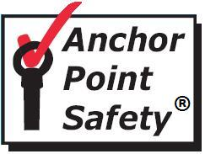 | Ph: 1800 007 454  Email:admin@anchorpointsafety.com.au  Website:www.anchorpointsafety.com.au

Installation Certificate 021215/1

04057
Client |  | Strata Plan 52948
Location |  | Cnr Fontenoy Road and Lane Cove Road Macquarie Park
Product |  | Roof Safety |  |  | Installed date |  |  |  | 29/11/2015
The above project is offered for hand-over to the customer.
The following associated items are also provided: 041057
Drawings  Manuals  Spare parts  Training  Other |  |  | N/A
 |  |  | N/A
 |  |  | N/A
 |  |  | N/A
The Compliance period will commence from the above completion date and expire on: |  |  |  |  |  |  | 28/11/2016
NOTE. Compliance. At the time of inspection.
- Anchors were inspected in accordance with Australian Standard 1891/4, 2009 & Workcover Acts and Regulations, Codes of Practice and accepted industry mode of installation.

- Anchors comply with all requirements and are rated as Limited Free Fall
12kns

.
- Roof Anchors should be inspected prior to use by the operator and at regular intervals not greater than twelve months by a competent person.

- All operators should be competent in working at height and with safety equipment.

No. | Items installed or inspected |  |  |  |  |  |  | Date
1 | Concrete Anchor Points |  |  |  |  |  |  | 29/11/2015
 | 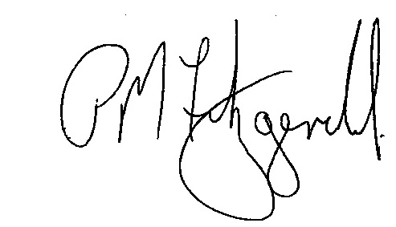
Anchor Point Safety |  |  |  |  |  | Date |  | 2/12/2015

